ARE YOU A CANCER VICTIM/SURVIVOR?
ARE YOU INTERESTED IN THE HEALTH EFFECTS FROM THE TRINITY TEST?
THEN PLAN ON ATTENDING THE 5th ANNUAL
LUMINARIA LIGHTING AND PRAYER VIGIL
JULY 26, 2014
7:00 PM-10:00 PM WITH OPENING REMARKS BEGINNING AT 8:00 PM
Tularosa Little League Field, La Luz Rd. and Wildcat Loop
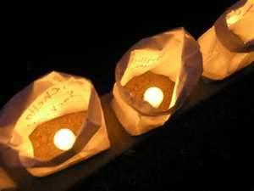
Sponsored by: The Tularosa Basin Downwinders Consortium (TBDC) in cooperation with the Village of Tularosa

Luminarias will be available for a suggested donation of $1.00 in memory of those who have died from cancer
To volunteer or for information contact:
Kathy Tyler 575-585-2896 fotyler@tularosa.net
Tina Cordova 505-897-6787 tcordova@queston.net

COME AND PARTICIPATE IN A HEALING SERVICE WITH A NATIVE AMERICAN MEDICINE MAN AS WELL AS OTHER FAITH LEADERS
OUR CONGRESSIONAL REPRESENTATIVES AND OUR LEGISLATORS HAVE BEEN INIVTED TO ATTEND ALONG WITH OTHER DIGNITARIES.

YOU WON’T WANT TO MISS THIS BEAUTIFUL AND HEALING EVENT

