7TH ANNUAL CANDLELIGHT VIGIL
TO COMMEMORATE THE TRINITY TEST, MEMORIALIZE THOSE THAT HAVE LOST THEIR LIVES TO CANCER
AND HONOR THOSE WHO ARE LIVING WITH OR WHO HAVE SURVIVED CANCER

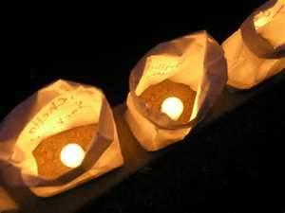
JULY 16, 2016
PROGRAM STARTS AT 8:00 PM
LUMINARIAS ON SALE FOR SUGGESTED DONATION OF $1.00 STARTING AT 7:30 PM
TULAROSA LITTLE LEAGUE FIELD ON LA LUZ AVE. IN WEST TULAROSA

PLEASE COME AND SHARE IN THIS SOMBER TRIBUTE AND LEARN ABOUT HOW YOU CAN HELP WITH POSSIBLE COMPENSATION THROUGH THE RADIATION EXPOSURE COMPENSATION ACT.
For more information or to volunteer please contact
Tina Cordova at 505-897-6787 tcordova@queston.net or
Kathy Tyler at 575-585-2896 or fotyler@tularosa.net

