7TH ANNUAL CANDLELIGHT VIGIL
TO ACKNOWLEDGE THE NEGATIVE HEALTH EFFECTS ON THE PEOPLE OF NEW MEXICO FROM THE TRINITY TEST
MEMORIALIZE THOSE THAT HAVE LOST THEIR LIVES TO CANCER
AND HONOR THOSE WHO ARE LIVING WITH OR WHO HAVE SURVIVED CANCER

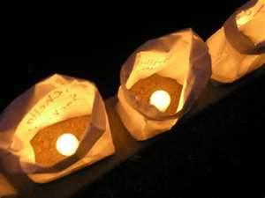
SATURDAY, JULY 16, 2016
PROGRAM STARTS AT 8:00 PM
LUMINARIAS ON SALE FOR SUGGESTED DONATION OF $1.00 EACH STARTING AT 7:30 PM
TULAROSA LITTLE LEAGUE FIELD ON LA LUZ AVE. IN WEST TULAROSA

PLEASE COME AND SHARE IN THIS SOMBER TRIBUTE AND LEARN ABOUT OUR HEALTH SURVEY AND POSSIBLE COMPENSATION THROUGH THE RADIATION EXPOSURE COMPENSATION ACT.

For more information or to volunteer, please contact:
Tina Cordova at 505-897-6787 tcordova@queston.net
Kathy Tyler at 575-585-2896 fotyler@tularosa.net

