10TH ANNUAL

CANDLELIGHT VIGIL Saturday, July 21, 2019 | 7:30PM
Tularosa Little League Field
TO ACKNOWLEDGE THE
NEGATIVE HEALTH EFFECTS
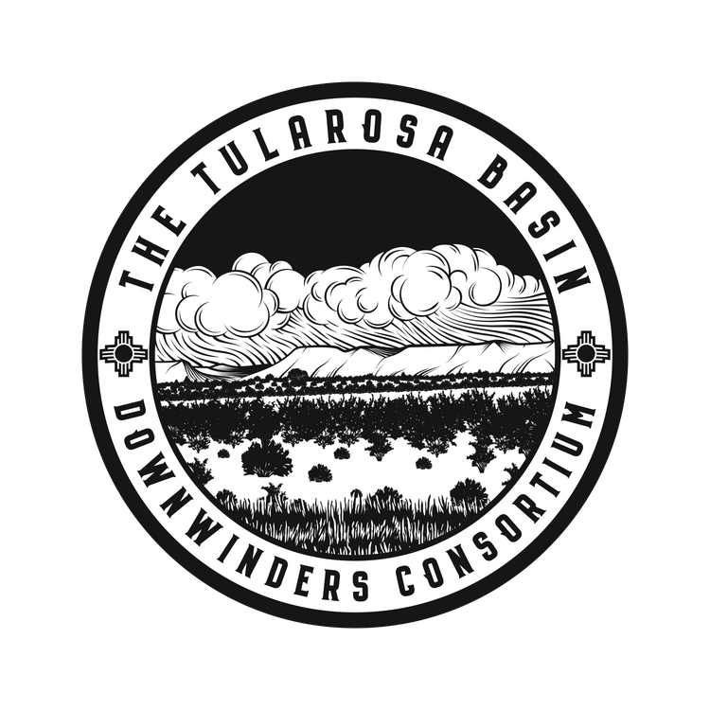
SUFFERED BY THE PEOPLE OF
NEW MEXICO FROM THE
TRINITY TEST

MEMORIALIZE LOVED ONES
WHO HAVE LOST THEIR LIVES
TO CANCER AND HONOR THOSE
WHO ARE LIVING WITH OR WHO HAVE SURVIVED CANCER

For more information, please contact:
Tina Cordova: (505) 897-6787 or tcordova@queston.net www.trinitydownwinders.com

