Joseph J. Shonka, Ph.D.
“The First Dirty Bomb: Trinity”
Thursday, November 7th | 6:00pm-8:00pm
Center for the Arts, Little Theater, Northern New Mexico College, Espanola, New Mexico
The Tularosa Basin Downwinders Consortium (TBDC) invites you to hear Dr. Joseph J. Shonka present his lecture, “The First Dirty Bomb, Trinity” at Northern New Mexico College.
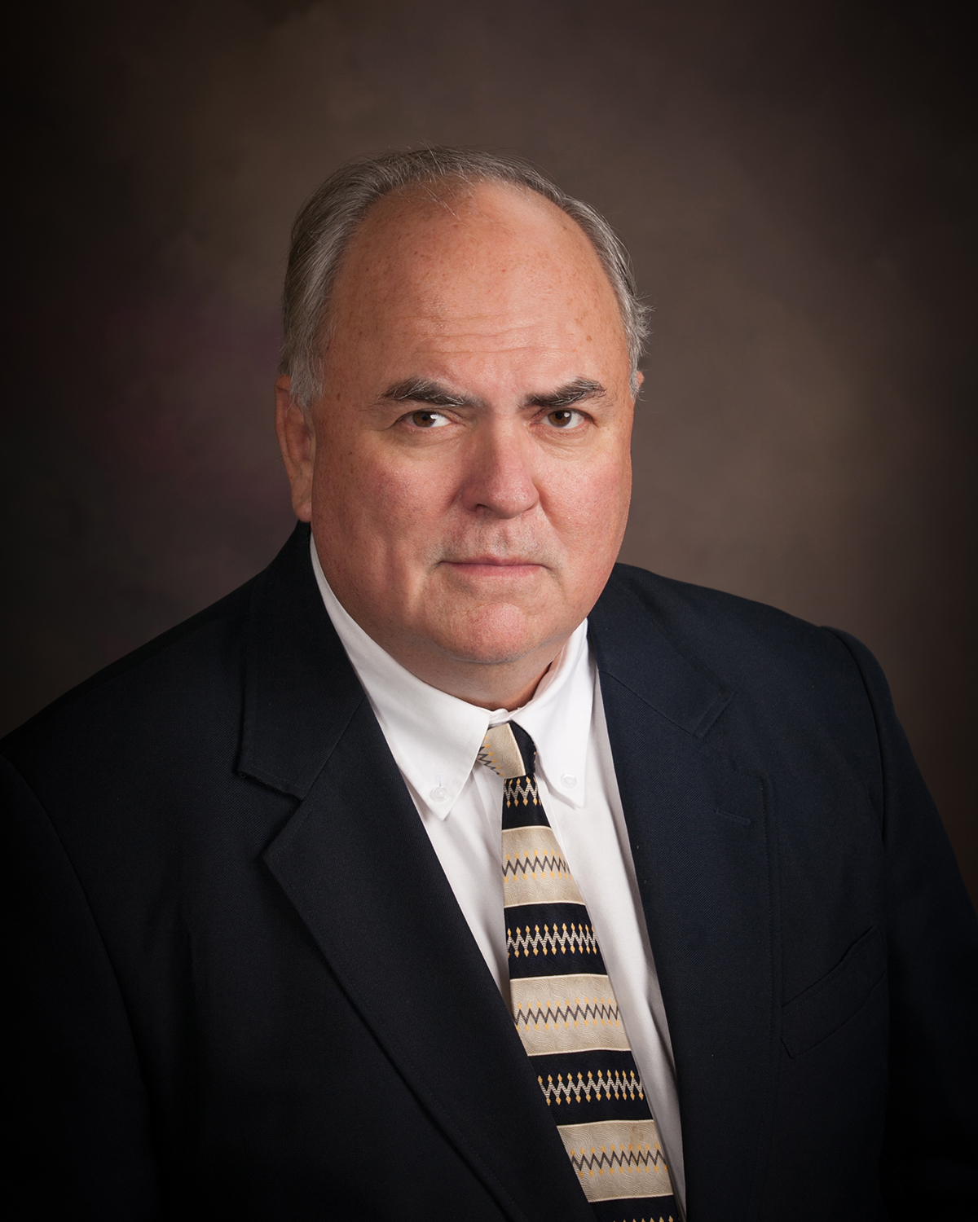
Dr. Shonka worked extensively on the Los Alamos Historical Document Retrieval and Assessment (LAHDRA) study and is an expert on the Trinity test of July 16, 1945. LAHDRA was a ten-year study conducted on behalf of the Centers for Disease Control and Prevention. Chapter 10 of the study focuses on the Trinity test.
Dr. Shonka is a Senior Health Physicist / Nuclear Engineer with over 40 years of experience. Dr. Shonka’s work in Nuclear Engineering and Health Physics includes extensive experience at three of the U.S. National Laboratories. He has served as a consultant to the NRC and DOE and for many of the commercial nuclear power plants in the U.S.

Co-Sponsors:
Tularosa Basin Downwinders Consortium
Interfaith Worker Justice – New Mexico
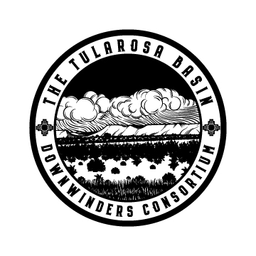
New Mexico Health Equity Partnership, an initiative at the Santa Fe Community Foundation
HOPE: Honor Our Pueblo Existence
Tewa Women United

