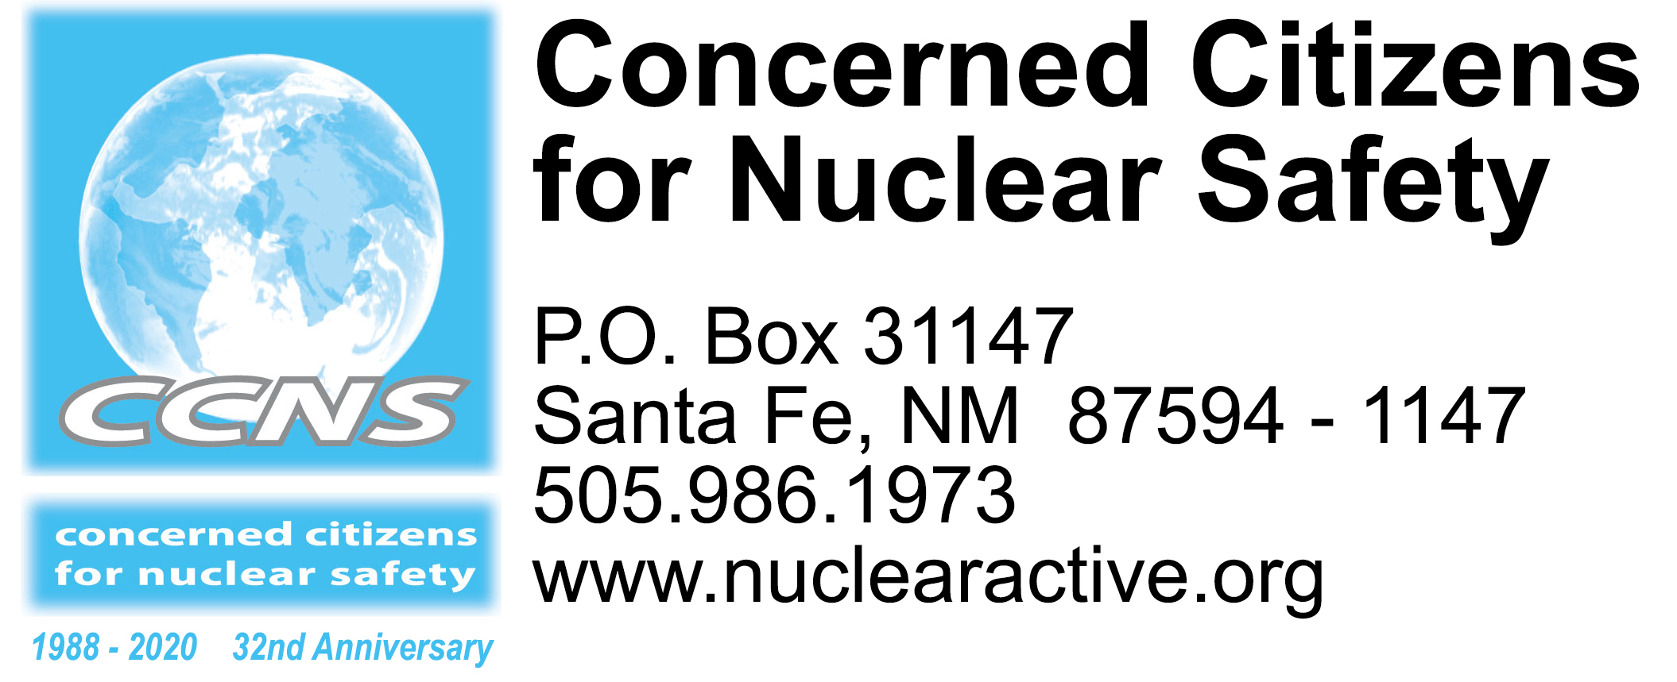

2020 Commemoration & Stop the New Nuclear Arms Race Events
Mark your calendar and join us!
Revised February 6, 2020 – A listing of acronyms available at end

Sun. Feb. 9 Joni Arends, CCNS Co-founder and Executive Director, will present “The Department of Energy’s Plans to Expand LANL and WIPP and What You Can Do,” at 11 am at Journey Santa Fe at Collected Works Bookstore, 202 Galisteo Street, Santa Fe. We’ll have petitions & postcards you can sign. The event is free and open to the public.

Mon. Feb. 10 Anticipated release of federal budget. To learn what to look for in the U.S. DOE’s Fiscal Year 2021 Nuclear Weapons and Cleanup Budget Request, check out the Alliance for Nuclear Accountability’s Media Advisory. http://www.ananuclear.org/ and scroll down the home page.

Tues. Feb. 11 Beginning at 11 am, we’ll deliver the signed petitions to the congressional offices in Santa Fe.

Wed. Feb. 19 LANL will host an “Environmental Management Cleanup Forum about Legacy Waste at LANL,” at the Cottonwood on the Greens, 4244 Diamond Drive from 5:30 to 7:15 pm. Topics include Cleanup: Big Picture and Near-Term Decisions with a Community Discussion and Q&A, along with a Poster Session. https://www.cottonwoodonthegreens.com/

Th. Feb. 20 Public comments due to NMED about WIPP pre-submittal permit renewal application. Sample public comment letter will be available soon at http://nuclearactive.org/

Th. Feb. 27 Public comments due to EPA about LANL’s Industrial Wastewater Discharge Permit. Sample public comment letter will be available soon at http://nuclearactive.org/

Wed. Mar. 11 Public comments due to NMED about groundwater discharge permit (DP-1481) for URENCO, a uranium enrichment facility located near Eunice, NM and the NM/TX border. Sample public comment letter will be available soon at http://nuclearactive.org/

Sun. Mar. 15 Tularosa Basin Downwinders Consortium Third Annual Fundraiser at the National Hispanic Cultural Center from 1 to 5 pm. Music, food, silent auction, raffle tickets, fun! https://www.trinitydownwinders.com/

Tues. Mar. 31 Public comments due to EPA about LANL’s Individual Stormwater Permit. Sample public comment letter will be available soon at http://nuclearactive.org/

End of March NRC draft environmental impact statement for proposed Holtec Consolidated Interim Storage Facility in NM to be released for public review and comment. Public meetings will be held throughout NM.
Sat. Apr. 4 Tularosa Basin Downwinders Consortium (TBDC) peaceful demonstrations at the openings of Trinity Site at Tularosa Gate (8 – 9 am) and Stallion Gate (9 am – 1 pm) https://www.trinitydownwinders.com/
Sun. Apr. 19 – Wed. Apr. 22 • 32nd Alliance for Nuclear Accountability (ANA) DC Days in Washington, DC. Join ANA as we voice our concerns about nuclear weapons, power, and waste to key congressional offices, administration offices, and the media. Youth scholarships available. http://www.ananuclear.org/
Mon. Apr. 27 – Fri. May 22 • 2020 Nuclear Non-Proliferation Treaty Conference at the United Nations in New York. https://meetings.unoda.org/meeting/conf-npt-2020/
Fri. May 22 – Mon. May 25 • Stop the New Nuclear Arms Race, Maryville, TN. http://nukewatchinfo.org/stop_new_nuclear_arms_race/

May NRC draft environmental impact statement for proposed Waste Control Specialists/Interim Storage Partners/Orano Consolidated Interim Storage Facility covering the NM/TX border released for public review and comment.

Sat. June 13 2020 Presentations from 6:30 – 8 pm at the Methodist Church, 1300 Girard NE, Albuquerque. Stay tuned for more details.

Wed. July 15 – 16 • The Gospel of Nonviolent Love: Vigil for Universal Nonviolence
at the Trinity Site. http://www.vigilforuniversalnonviolence.org/

Sat. July 18 • Candlelight Vigil for those who have died or live with cancer from over exposure to radiation from the July 16, 1945 Trinity test at the Tularosa Little League Field. https://www.trinitydownwinders.com/

Mid-July Commemoration of the July 16, 1979 Church Rock Uranium Spill

July Hazardous waste permit renewal applications due to the NMED from LANL and WIPP beginning administrative permitting processes for both facilities. The permits are for 10 years.

Wed. Aug. 5 • Veterans for Peace National Convention, Aug. 5 – 9, Albuquerque and Los Alamos, NM. https://www.veteransforpeace.org/
• Upaya Zen Center “Bearing Witness Memorial Sesshin: Marking the 75th Year Since the Nuclear Bombings,” Aug. 5 – 10, Santa Fe and Los Alamos, NM. https://www.upaya.org/

Th. Aug. 6 Coordinated activities in Los Alamos, from 4 - 8 pm
- 4 pm - Sackcloth and ashes silent contemplative sitting to commemorate the 75th anniversary of the U.S. atomic bombing of Hiroshima, followed by a silent procession around Ashley Pond
- 5 pm – Rally at Main Stage with speakers, poets, and musicians
- 8 pm - A lit candle will float on the pond in solidarity with the people of Hiroshima

Fri. Aug. 7 – Sat. Aug. 8 • Campaign Nonviolence National Conference, Hotel Albuquerque, NM. https://paceebene.org/

Sat. Aug. 8 PaxChristi Conference from 7 to 9 pm at the Hotel Albuquerque, NM. https://paxchristiusa.org/

Sun. Aug. 9 Coordinated activities in Los Alamos, from 11 am – 3 pm
- 11 am – Sackcloth and ashes silent contemplative sitting at Ashley Pond to commemorate the 75th anniversary of the U.S. atomic bombing of Nagasaki, followed by a silent procession around Ashley Pond
- Noon – 3 pm – Rally at Main Stage with speakers, poets and musicians

Late Sept. Early Oct. • Tewa Women United Gathering for Mother Earth. http://tewawomenunited.org/

Sat. Oct. 3 Tularosa Basin Downwinders Consortium (TBDC) peaceful demonstrations at the openings of Trinity Site at Tularosa Gate (8 – 9 am) and Stallion Gate (9 am – 1 pm) https://www.trinitydownwinders.com/

ACRONYMS

DOE Department of Energy
EPA Environmental Protection Agency
LANL Los Alamos National Laboratory
NMED New Mexico Environment Department
NNSA National Nuclear Security Administration
WIPP Waste Isolation Pilot Plant

