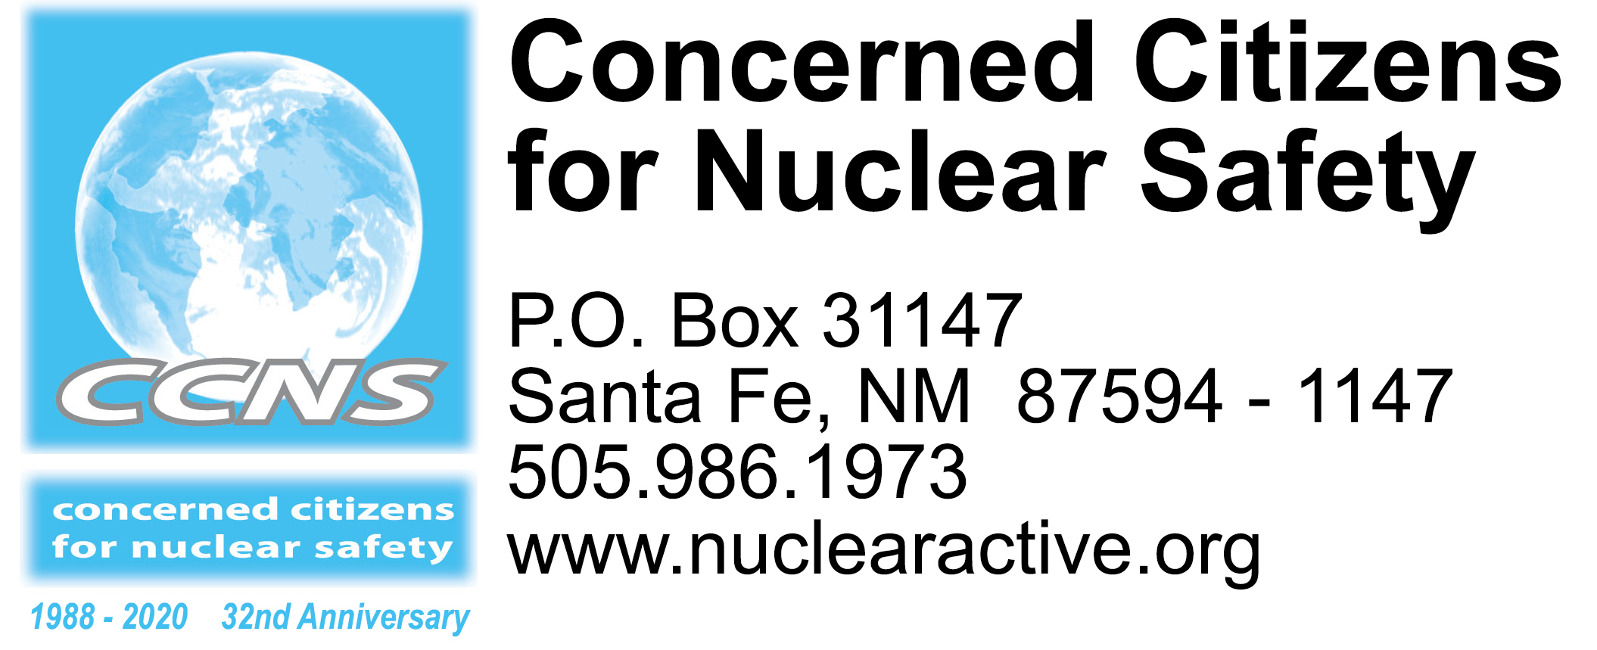

2020 Commemorations & Stop the New Nuclear Arms Race Events
Mark your calendar and join us!
Revised March 5, 2020 – A listing of acronyms available at end

Th. Mar. 5 Uranium Public Hearings of the Naabik’íyáti’ Committee of the 24th Navajo Nation Council about the ongoing abandoned uranium mine clean-up position and policy development priorities. The Committee would like to hear from Navajo community members and workers that have been impacted by the mining, transport, processing, and proximity of uranium ore mining operations in the Navajo Nation’s history. The first hearing will be held at the South Campus Lecture Hall, Diné College, Shiprock, NM, beginning at 9 am. For more information, contact the Office of the Speaker at (928) 871-7160.

Fri. Mar. 6 Uranium Public Hearings at Navajo Technical College, Crownpoint, NM. See first entry above for more information.

Tues. Mar. 10 Deliver signed programmatic EIS (PEIS) before LANL site-wide EIS (SWEIS) petitions to Senators Udall and Heinrich and Representative Lujan and then to Governor Lujan Grisham. Meet at 2 pm at St. Francis statute at the corner of Marcy & Lincoln (Santa Fe City Hall). Download the petition, gather signatures and bring them with you. http://nuclearactive.org/

Wed. Mar. 11 Public comments due to NMED about groundwater discharge permit (DP-1481) for URENCO, a uranium enrichment facility located near Eunice, NM and the NM/TX border. Short fact sheet and sample public comment letter will be available soon at http://nuclearactive.org/

Fri. Mar. 13 Uranium Public Hearings at To Be Announced (TBA), Chinle, AZ. See first entry above for more information.

Sat. Mar. 14 Uranium Public Hearings at To Be Announced (TBA), Tuba City Chapter, AZ. See previous entry for more information.

Sun. Mar. 15 Tularosa Basin Downwinders Consortium Third Annual Fundraiser at the National Hispanic Cultural Center from 1 to 5 pm. Music, food, silent auction, raffle tickets, fun! https://www.trinitydownwinders.com/

Tues. Mar. 31 Public comments due to EPA about LANL’s Individual Stormwater Permit and Industrial Wastewater Permit (outfalls). Sample public comment letters will be available soon at http://nuclearactive.org/

End of March NRC draft environmental impact statement (DEIS) for proposed Holtec Consolidated Interim Storage Facility (CISF) in NM to be released for public review and comment. Public hearings will be held throughout NM.

NMED comments about the proposed CISF on NRC website: https://adamswebsearch2.nrc.gov/webSearch2/main.jsp?AccessionNumber=ML20065K031

Sat. Apr. 4 Tularosa Basin Downwinders Consortium (TBDC) peaceful demonstrations at the openings of Trinity Site at Tularosa Gate (8 – 9 am) and Stallion Gate (9 am – 1 pm) https://www.trinitydownwinders.com/
Tue. Apr. 14 Roswell, NM - NRC public hearing for Holtec DEIS Consolidated Interim Storage Facility. Details to follow.
Wed. Apr. 15 Hobbs, NM - NRC public hearing for Holtec DEIS Consolidated Interim Storage Facility. Details to follow.
Th. Apr. 16 Carlsbad, NM - NRC public hearing for Holtec DEIS Consolidated Interim Storage Facility. Details to follow.
Sun. Apr. 19 – Wed. Apr. 22 • 32nd Alliance for Nuclear Accountability (ANA) DC Days in Washington, DC. Join ANA as we voice our concerns about nuclear weapons, power, and waste to key congressional offices, administration offices, and the media. Youth scholarships available. http://www.ananuclear.org/
Wed. Apr. 22 – Sun. Apr. 26 • Taos Environmental Film Festival – Apr. 22 will be at SOMOS (Society of the Muse of the Southwest). Apr. 23 – 26 will be at the Taos Community Auditorium. For more information, contact jeanstevens@hotmail.com
Mon. Apr. 27 – Fri. May 22 • 2020 Nuclear Non-Proliferation Treaty Conference at the United Nations in New York. https://meetings.unoda.org/meeting/conf-npt-2020/
Tue. May 5 Albuquerque, NM - NRC public hearing for Holtec DEIS Consolidated Interim Storage Facility. Details to follow.

Wed. May 6 Gallup, NM - NRC public hearing for Holtec DEIS Consolidated Interim Storage Facility. Details to follow.

Fri. May 22 – Mon. May 25 • Stop the New Nuclear Arms Race, Maryville, TN. http://nukewatchinfo.org/stop_new_nuclear_arms_race/

May NRC draft environmental impact statement for proposed Waste Control Specialists/Interim Storage Partners/Orano Consolidated Interim Storage Facility covering the NM/TX border released for public review and comment.

Sat. June 13 2020 Presentations from 6:30 – 8 pm at the Methodist Church, 1300 Girard NE, Albuquerque. Stay tuned for more details.

Wed. July 15 – 16 • The Gospel of Nonviolent Love: Vigil for Universal Nonviolence
at the Trinity Site. http://www.vigilforuniversalnonviolence.org/

Sat. July 18 • Candlelight Vigil for those who have died or live with cancer from over exposure to radiation from the July 16, 1945 Trinity test at the Tularosa Little League Field. https://www.trinitydownwinders.com/

• Commemoration of the July 16, 1979 Church Rock Uranium Spill. https://swuraniumimpacts.org/

July Hazardous waste permit renewal applications due to the NMED from LANL and WIPP beginning administrative permitting processes for both facilities. The permits are for 10 years.

Wed. Aug. 5 • Veterans for Peace National Convention, Aug. 5 – 9, Albuquerque and Los Alamos, NM. https://www.veteransforpeace.org/
• Upaya Zen Center “Bearing Witness Memorial Sesshin: Marking the 75th Year Since the Nuclear Bombings,” Aug. 5 – 10, Santa Fe and Los Alamos, NM. https://www.upaya.org/

Th. Aug. 6 Coordinated activities in Los Alamos, from 4 - 8 pm
- 4 pm - Sackcloth and ashes silent contemplative sitting to commemorate the 75th anniversary of the U.S. atomic bombing of Hiroshima, followed by a silent procession around Ashley Pond
- 5 pm – Rally at Main Stage with speakers, poets, and musicians
- 8 pm - A lit candle will float on the pond in solidarity with the people of Hiroshima

Fri. Aug. 7 – Sat. Aug. 8 • Campaign Nonviolence National Conference, Hotel Albuquerque, NM. https://paceebene.org/

Sat. Aug. 8 PaxChristi Conference from 7 to 9 pm at the Hotel Albuquerque, NM. https://paxchristiusa.org/

Sun. Aug. 9 Coordinated activities in Los Alamos, from 11 am – 3 pm
- 11 am – Sackcloth and ashes silent contemplative sitting at Ashley Pond to commemorate the 75th anniversary of the U.S. atomic bombing of Nagasaki, followed by a silent procession around Ashley Pond
- Noon – 3 pm – Rally at Main Stage with speakers, poets and musicians

Late Sept. Early Oct. • Tewa Women United Gathering for Mother Earth. http://tewawomenunited.org/

Sat. Oct. 3 Tularosa Basin Downwinders Consortium (TBDC) peaceful demonstrations at the openings of Trinity Site at Tularosa Gate (8 – 9 am) and Stallion Gate (9 am – 1 pm) https://www.trinitydownwinders.com/

ACRONYMS

CISF Consolidated Interim Storage Facility (for high-level radioactive waste)
DEIS draft Environmental Impact Statement
DOE Department of Energy, a federal agency
EIS Environmental Impact Statement
EPA Environmental Protection Agency, a federal agency
LANL Los Alamos National Laboratory, a DOE/NNSA facility
NMED New Mexico Environment Department
NNSA National Nuclear Security Administration, a federal semi-autonomous agency
NRC Nuclear Regulatory Commission, a federal agency
WIPP Waste Isolation Pilot Plant, a DOE facility

