Henry P. Roybal  Commissioner, District 1 | 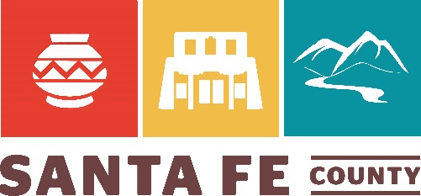 | Anna T. Hamilton  Commissioner, District 4
Anna Hansen  Commissioner, District 2 |  | Hank Hughes  Commissioner, District 5
Rudy N. Garcia  Commissioner, District 3 |  | Katherine Miller  County Manager

October 6, 2021

Via email: Sarah.Propst@state.nm.us

Cabinet Secretary Sarah Cottrell Propst
Chair, Radioactive Waste Consultation Task Force
New Mexico Energy, Minerals and Natural Resources Department
1220 South St. Francis Drive
Santa Fe, NM 87505

Re: Comments for October 6, 2021 Task Force Meeting

Dear Cabinet Secretary Propst and Task Force Members:

I provide these comments today in my capacity as Santa Fe County Commissioner, District 2. My constituents are very concerned about the plans of the Department of Energy (DOE) to double the size of the Waste Isolation Pilot Plant (WIPP). DOE is breaking its agreements with the People of New Mexico to limit the types and amounts of waste, as well as to operate for 25 years and then close.

Preparing the WIPP site with a proposed Shaft No. 5, associated underground drifts, two new waste disposal panels, and proposed Salt Storage Cell No. 5 and Salt Cell No. 5 (evaporation pond) without complying with the requirements of the Consultation and Cooperation (C&C) Agreement between DOE and the State of New Mexico, is improper at best.

My constituents are greatly concerned about DOE plans to ship plutonium cores (the triggers for nuclear weapons) from the Pantex Site, north of Amarillo, Texas, through New Mexico and on State Road 599 (portions of which are in District 2) to Los Alamos National Laboratory (LANL) for processing. The processed plutonium would then be shipped, again on S.R. 599, to the Savannah River Site in South Carolina for further processing. The 3,300-mile trip would be completed when the processed plutonium would be shipped to WIPP for disposal in the proposed panels.

It is time for the State of New Mexico to respond – and this meeting is an important first step – by invoking the C&C Agreement at its earliest convenience. Please let me know how I can be of assistance to the Task Force.

Sincerely,
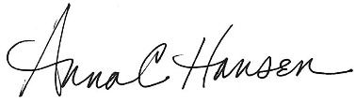

Santa Fe County Commissioner Anna Hansen, District 2
ahansen@santafecountynm.gov
102 Grant Ave, Santa Fe, NM 87501

cc:
NMED: James.Kenney@state.nm.us
NMDOH: David.Scrase@state.nm.us
NMDOT: Michael.Sandoval1@state.nm.us
NMDPS: Jason.Bowie@state.nm.us
NMDHS&EM: Bianca.Ortiz-Wertheim@state.nm.us
Sen. Steinborn: jeff.steinborn@nmlegis.gov
Rep. Chandler: christine.chandler@nmlegis.gov
EMNRD WIPP Bureau Chief: wipp.coordinator@state.nm.us

